WORKSHEET – CH- 6 - MARGINALISATION AND SOCIAL JUSTICE
STD: VIII
I. ANSWER THE FOLLOWING:
1. Define Marginalization, Untouchables.
2. In what ways Indian constitution aims to protect the Scheduled Caste people.
3. Who were called as Scheduled Tribes?
4. List out any four tribal communities and their regions.
5. Expand and explain OBC.
6. Who were comes under minorities in India?
7. How many religions where listed under minorities? Who are they?
8. In what way women are marginalized by the Indian society?
9. Name any two social reformers who worked for the betterment of women in India,
10. Which is the highest national body set up for the women welfare in India?
11. Expand NCW.
12. What do you mean Reservation?
13. The scheduled castes are also known as Adivasis. (Agree/ Disagree)
14. What is the percentage of seats reserved in government institutions for the Other Backward Classes?
(a) 15 (b) 7.5 (c) 27 (d) 35
15. Which of the following bodies was set up to examine the issue of reservation and quota for the upliftment of Other Backward Classes?
(a) Sachar Committee (b) Mandal Commission (c) National knowledge commission (d) Kaka Kelkar Commission
16. Muslims are considered a minority in India. (Agree/Disagree)
17. Expand UNICEF and its objectives.
18.The Mandal commission was set up in ---------------.
19. State arguments to support or oppose the following assertion:
Hindu community is declared a minority by the Union Government.
20. In the question given below, there are two statements marked as Assertion ( A) and Reason ( R ). Read the statements and chose the correct option:
ASSERTION: (A)
As per our Indian Constitution both men and women shall get equal pay for work.
REASON: ®
In India Government schools have been set up to provide free education for children.
a. Both A and R are true and R is the correct explanation of A.
b. Both A and R is true but R is not the correct explanation of A.
c. A is correct but R is wrong.
d. A is wrong but R is correct.
21. In the question given below, there are two statements marked as Assertion ( A) and Reason ( R ). Read the statements and chose the correct option:
ASSERTION: (A)
The Mandal Commission was set up in 1979, under the chairmanship of B.P.Mandal.
REASON; (R)
Mandal commission started mainly for upliftment of backward classes other than SC and ST.
a. Both A and R are true and R is the correct explanation of A.
b. Both A and R is true but R is not the correct explanation of A.
c. A is correct but R is wrong.
d. A is wrong but R is correct.
22.
COLUMN A | COLUMN B
1) Apatani tribe | a) Scheduled Caste
2)Dalits | b) Abolition of Polygamy
3) Integrated Child Development Scheme | c) look into the socio-economic development of the ST.
4) Child Labour Act, 2006 | d) Arunachal Pradesh
5) Hindu Marriage Act | e) look into the welfare of Scheduled caste and OBC
6)Other Backward Classes | f) Child below 14 is prohibited
7) Ministry of Social Justice and Empowerment | g) Government of India launched for the betterment of children.
8) The Ministry of Tribal affairs | h) 27% of reservation in government jobs

23. Identify the scheme provided in schools for the children.
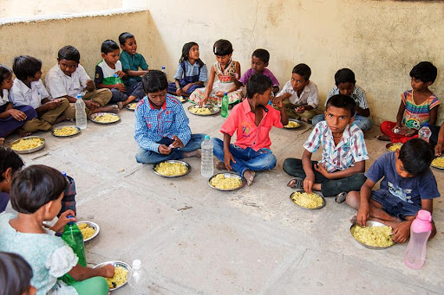

24. Identify the group of women who is doing handicrafts.
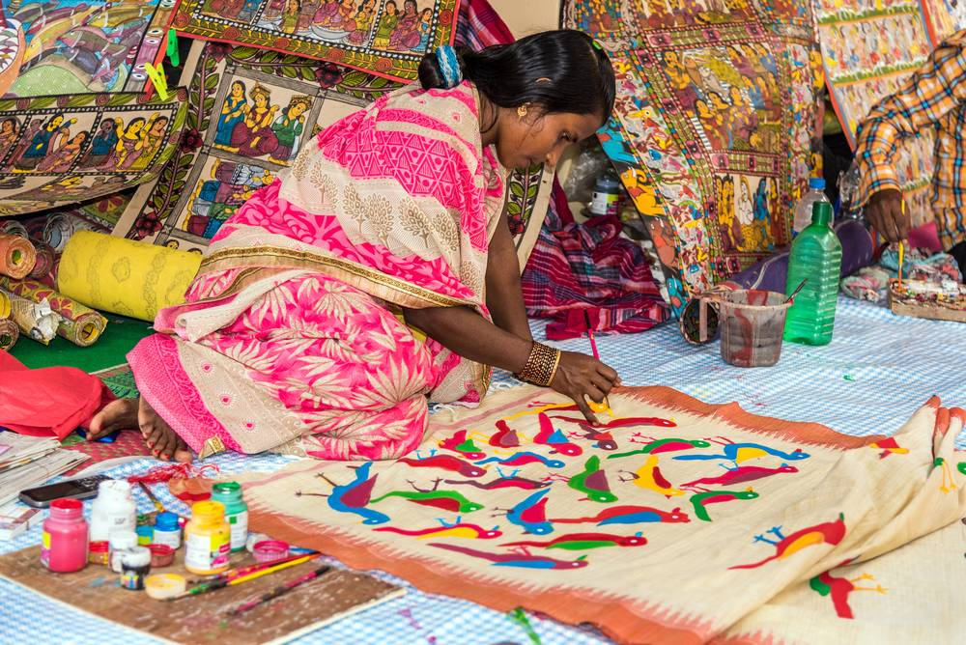

25. How many number of seats are reserved for women in Panchayats and Chairpersons?
